**CCLA INVESTMENT MANAGEMENT LIMITED PSDF(22)P10**

**The Public Sector Deposit Fund Advisory Board**

**Stress Tests Reports**

Money Market Fund Regulation introduced a number of rules which the Public Sector Deposit Fund (PSDF) must follow. As part of prudent risk management, Article 28 of the rules require Managers to have a stress testing procedure in place based on hypothetical scenarios and that such stress testing should take place at least bi-annually.

Stress tests are conducted at a frequency determined by the ACD, after considering what an appropriate and reasonable interval is, in light of the market conditions, and after considering any envisaged changes in the portfolio. Stress tests are currently carried out on a monthly basis by the Investment Risk function and shared with the Cash Management Team. The PSDF is a Low Volatility Net Asset Value (LVNAV) Money Market Fund under the regulations. In the case of LVNAV MMFs, stress testing estimates for different portfolio scenarios as well as publication of the difference between the constant NAV per share and the shadow NAV per share.

The stress events are based on objective criteria and consider the effects of severe plausible scenarios. In addition to these the fund managers monitor other tests on a daily basis. The summary from the latest stress tests can be found below:

**PSDF Stress Testing – Summary of the tests at the end of last month**

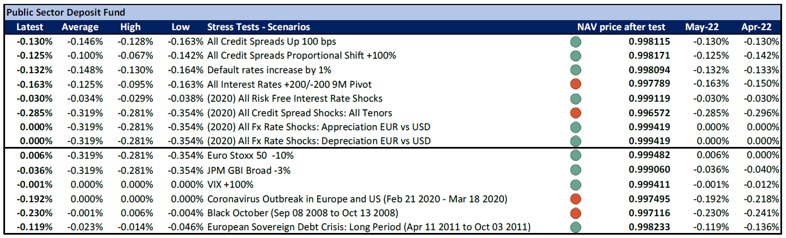

A series of stress tests were undertaken using the end of month holdings as at 31 May 2022. We closely monitor 12 of Confluence's stress tests (as shown by the chart on page 1), six relate to interest rate movements and the other six are macro-economic tests. The assumptions for the stress tests with a “2020” label have been updated by ESMA following the COVID-19 crisis to use more conservative assumptions, due to the extreme market movements observed during March 2020. Futher ammendments by ESMA to these assumptions are expected in the next quarter.

There are currently four scenarios that would break the Fund’s LVNAV 20 basis point collar at the end of April.

* The first two scenarios are the “Black October” and the “Coronavirus Outbreak” scenario which if it were to occur now could result in the Fund’s LVNAV falling by -0.230% and -0.192% respectively. As has been mentioned before, these are "once in a decade" economic shock, highly unlikely to reoccur in the near term.
* The third scenario is “All interest rates +/-200bps 9m pivot”, this scenario would not usually lead to an excess in the LVNAV collar, but in this Report, if the scenarios had occurred and CCLA not taken any defensive measures, then the Fund could have marginally broken the lower collar boundary. This scenario’s results can be explained with the current context of repricing of interest rates, which has led to a severe steepening of the yield curve. The portfolio’s longer tenure holdings, which were generally purchased in the second half of last year (featuring very low coupons), are more sensitive to this type of repricing. The portfolio managers have been monitoring carefully the severity of the Shadow NAV fall, and to help alleviate the negative impact, they have been reducing the Fund's WAM in the last few months. It is thus reasonably expected that the Fund's Shadow NAV will revert closer to Par, unless there is a significant change in the Bank of England's monetary policy. Taking into consideration the stress tests results in the above context and together with the actions undertaken within the Fund, there are no concerns in regards of this scenario.
* The fourth scenario which would break the Fund’s 20 basis point collar is “All Credit Spread Shocks: All Tenors”. This scenario assumes that credit spreads for corporate credit at all tenors rise by 220 – 310 basis points depending on its credit rating. This stress test has been updated significantly post COVID making it more severe. As can be seen by the chart on page 1, this is the most stringent scenario and would cause the Fund’s LVNAV to fall by -0.285 % to 0.996572.

All other stress tests show that the Fund’s price would remain within its LVNAV collar.

Given the above, I am happy to confirm I have no concerns with the stress test results of the PSDF.

**Federico Sassoli de Bianchi  
Investment Risk Manager**