CCLA INVESTMENT MANAGEMENT LIMITED PSDF(22)P12

The Public Sector Deposit Fund Advisory Board

Counterparty List and Rating Action

Summary
- Rating changes have been mostly positive since we last met, albeit thin on the ground. Three banks on our approved list saw positive action including Lloyds and one of our overnight providers had a new rating initiated by DBRS. Agencies are continuing to cite balance sheet improvement and cost reduction as the principal drivers; however, we are increasingly seeing positive comments from rating agencies pertaining to the impact of higher policy rates on net interest margins
- Acquisitions continue with Royal Bank of Canada buying Brewin Dolphin while BNP express an interest in buying ABN Amro.
- Soc Gen, Citigroup, BNP Paribas and Crédit Agricole look to end operations in Russia
- HSBC are the subject of a greenwashing investigation by the Advertising Standards Authority and are in the news after suspending their Global Head of Responsible Investing after controversial remarks (he subsequently resigned on 7 July)
- In the early part of Quarter 1 Sterling corporate bonds and gilts had already started to re-price on the possibility that the Bank of England would begin Quantitative Tightening, the unfortunate events unfolding in Ukraine has caused an intense rise in yields. The bond markets are pricing in a decent amount of inflation and further rate hikes in the UK and globally
- Though the aggregate year-one revenue gives a boost from the interest rate increases for the banks, these are offset in terms of rising delinquencies and a slowdown in mortgage and consumer-credit growth. It shows how rapid rate hikes are a mixed blessing for banks, one of the reasons why the majority of bank share prices continue to show negative returns
- The cost of insuring financial institution defaults by the end of June had risen to the highest level in almost a decade. The consequences of the Ukraine conflict, the spike in the rate of inflation in double digits for many regions, and the higher transmission rates of Covid re-emerging creating nervousness.
(ai) Monthly rating changes – March 2022 *- = negative; *+ = positive
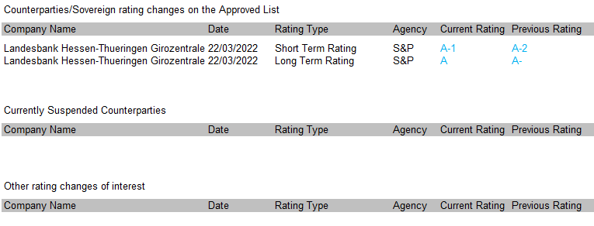
Counterparty rating changes
- There were very few rating changes of note during the month. S&P upgraded the short and long term rating of one of our important counterparties Landesbank Hessen-Thueringen Girozentrale (Helaba) to A-1 and A respectively. S&P said that they now expect that Helaba would be supported by the German Savings Banks Association (DSGV) under any foreseeable circumstances. S&P now believe that in the unlikely event that Helaba requires extraordinary support, DSGV would serve as the principal source of such support under all foreseeable circumstances. Their view primarily reflects a solid track record of increasing operational and strategic importance and Helaba's central sector role to DSGV in recent years. For example, Helaba is the exclusive payment processor for approximately 75% of nationwide German savings banks, and partners with more than two-thirds of German savings banks for their private banking and wealth management. In 2022, Helaba also took over Landesbank Baden-Württemberg's new business, with physical foreign notes and coins and precious metals as well as services for international payment transactions, as the central hub for the German savings bank sector. S&P’s assessment also follows a series of developments over recent months, including determined changes to the sector's institutional protection scheme, which will strengthen the ties between savings banks and Landesbanks in general, and several agreements between various Landesbanks for cooperation instead of consolidation strategies in the sector.
Other news
- A review of the UK’s ringfencing regime has concluded that it should be kept in place, disappointing many banks that had wanted to see the rules scrapped or relaxed. However, a panel of financial experts warned that over time the system’s inflexibility could stifle the country’s retail banking market and should eventually be superseded by newer regulations designed to oversee lenders deemed “too big to fail”.

Ringfencing was introduced after the huge state bailouts of the financial crisis and requires lenders with more than £25bn in deposits to formally separate consumer operations from their investment banking arms to protect ordinary customers. Despite lobbying from banks to scrap the rules entirely or increase the threshold, it should remain at £25bn, the panel led by Keith Skeoch, former Standard Life Aberdeen chief executive, recommended to the Treasury.

The review did, however, raise the prospect that some British lenders with “minimal investment banking activities” could be removed from the regime, reducing the associated costs and complexity of adhering to it. Of the seven banks subject to the rules, the Treasury could decide to release Santander UK, Virgin Money and TSB Bank, all of which have little or no trading operations and, therefore, very small ringfenced units. Their larger rivals Barclays, HSBC, NatWest and Lloyds would still have to comply. “The ringfencing regime has been successful in achieving some of its objectives of improving financial stability . . . [and is] worth retaining at present, but needs to be more adaptable, simpler, and more coherent with wider regulation,” Skeoch said.

- UBS has revealed it has $10m of loans outstanding to clients hit by western sanctions imposed in response to Russia’s invasion of Ukraine. The Swiss lender also announced in its annual report on that it has around $200m of exposure to Russian assets used as collateral in Lombard lending, which are loans secured against a portfolio of liquid assets like equities and bonds, and other secured financing. The world’s biggest wealth manager said that its direct risk exposure to Russia was $634m at the end of 2021, out of its total emerging market exposure of $20.9bn.

Russian wealth accounts for about 1% of annual foreign direct investment into Switzerland. But the Swiss government’s decision in February to break its tradition of political neutrality and match EU sanctions has made the country’s banks much less attractive to oligarchs.

- BNP Paribas and Crédit Agricole are to end all their business operations in Russia after its invasion of Ukraine. BNP, which had already said it would halt new financing deals, said it would stop processing other types of transactions. French peer Crédit Agricole, which similarly only has investment banking activities in Russia, said it would also halt all commercial activity there. BNP, the eurozone’s biggest bank, declined to comment on what would happen to its roughly 500 staff in Russia. Crédit Agricole has 170 staff in the country. BNP operates a retail bank in Ukraine, Ukrsibbank, and has previously revealed an exposure of €3bn to Ukraine and Russia, which it said amounted to 0.16% of its total. Crédit Agricole has said the two countries make up 0.45% of its total commercial commitments.

- NatWest is to buy back about 5% of its shares from the UK government for £1.2bn, reducing the Treasury’s voting rights in the lender to less than 50% for the first time since 2008. The off-market purchase of almost 550mn shares, equivalent to 4.9% of the stock in issue, means the Treasury will be left with a 48% stake in NatWest.

- Citigroup has agreed to sell its Indian retail business to local lender Axis Bank for $1.6bn as Jane Fraser, the US bank’s chief executive, drives a wider withdrawal from underperforming retail markets. The cash deal includes Citi’s credit cards, retail banking, wealth management and consumer loans in the country and will see 3,600 staff in India taken on by Axis, in a bet on a crowded sector already abandoned by a number of international lenders. “This is perhaps one of the best consumer franchises in the country,” Amitabh Chaudhry, chief executive of Axis said in Mumbai, Bloomberg reported. Fraser announced that Citi was putting subscale consumer businesses in 13 countries up for sale shortly after taking over as chief executive in March 2021, after years of internal contention over the far-flung retail network’s persistently low returns. The pullback, which affects markets including India, China and Poland, was designed to free up capital to be redeployed in other sections such as wealth management and institutional banking. Citi plans to focus its wealth management business through hubs in Singapore, Hong Kong, the United Arab Emirates and London.

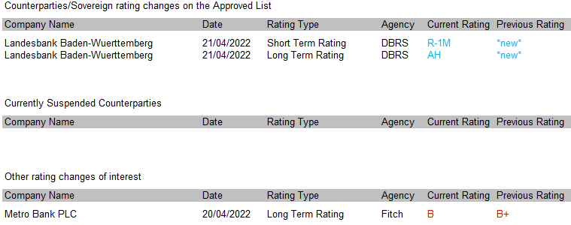
(aii) Monthly rating changes – April 2022 *- = negative; *+ = positive

Counterparty rating changes
- DBRS Ratings assigned first-time ratings to Landesbank Baden-Württemberg (LBBW), including Issuer Ratings at A (high) / R-1 (middle). The ‘A’ takes into account LBBW’s well established universal banking franchise with an emphasis on commercial clients and a regional focus on Southern Germany. The Bank acts as a central institution and clearing bank for the savings banks in its designated regions, has its own savings bank in Stuttgart, and has a growing asset and wealth management franchise. The Bank’s liquidity position is solid. LBBW has healthy capital ratios with cushions well above minimum requirements, which we expect to be maintained over the medium-term. The rating also takes into account the still modest earnings power, which is somewhat mitigated by the stability of earnings. Although DBRS expects to see an increase in profitability over time as the Bank implements its growth strategy, the repercussions from the war in Ukraine, measures by central banks globally to fight inflation and delayed effects from the COVID-19 pandemic could adversely affect profitability in the near-term. Risk is well managed and has benefitted from the relatively benign German economic environment, both of which are reflected in favourable asset quality metrics. However, some concentration risk exists, and the same factors affecting earnings could lead to weaker asset quality.

Other news
- Royal Bank of Canada (RBC) has said it will buy Brewin Dolphin for C$2.6bn (£1.6bn). The firm said this is a “transformative acquisition” for RBC Wealth Management. The deal is subject to Brewin Dolphin Holdings shareholder approval and receipt of all regulatory approvals.
Group head of RBC Wealth Management, RBC Insurance and RBC Investor & Treasury Services Doug Guzman said: “The UK is a key growth market for RBC, and Brewin Dolphin provides us with an exceptional platform to significantly transform our wealth management business in the region.”
- Canada’s top banks more than doubled their financing of highly polluting tar sands oil to $16.8bn in 2021, despite signing up to the UN’s net zero banking alliance on greenhouse gas emissions. Lenders including Royal Bank of Canada, Toronto-Dominion Bank and the Canadian Imperial Bank of Commerce increased their financing to the top 30 tar sands producers and six tar sands pipeline companies by almost $9bn in 2021, according to data from the Rainforest Action Network. All five Canadian banks, which also included Scotiabank and Bank of Montreal, committed last year to reaching net zero emissions by 2050 across their operations and portfolios when they joined the Net-Zero Banking Alliance. Tar sands are a growing source of Canadian emissions but also a large part of the economy. The five Canadian banks collectively have 13 directors with current or past close links to tar sands companies or groups supportive of the sector, according to data from DeSmog.

- Société Générale will take a €3.1bn hit after agreeing to exit Russia by selling Rosbank to an investment company founded by billionaire Vladimir Potanin. The French bank said it was selling its entire 99.98 per cent stake in Rosbank, as well as its Russian insurance operations, to Potanin’s Interros Capital after coming under scrutiny over its large exposure to the country following Russia’s invasion of Ukraine.

Along with Austria’s Raiffeisen Bank and Italy’s UniCredit, SocGen is one of the western European financial institutions with the largest presence in Russia, and the first of the three to have found a way to sell out.

“The closing of this operation should occur in the coming weeks,” SocGen said, adding it aimed to exit the country “in an effective and orderly manner”.

The group also said its core tier one capital ratio — which stood at 13.7 per cent at the end of December — would take a 20 basis point hit from the sale, adding that it still stood well above minimum regulatory thresholds.

- Citigroup’s profit nearly halved in the first quarter as the US bank warned of up to $3bn in potential losses linked to its Russian operations. Citi said it had set aside $1.9bn to cover loan losses, including $1bn for its Russian exposure and $900mn to cushion the blow from deteriorating economic conditions driven by inflation and soaring energy prices.

The fallout from the war is another challenge for chief executive Jane Fraser, who laid out her plan to improve profitability at the straggling US lender days after the Russian invasion began. Citi has accelerated efforts to reduce its exposure to Russia, which stood at $9.8bn as of the end of last year and fell to $7.8bn in the most recent quarter. The bank put its consumer operations in Russia up for sale a year ago and decided last month to exit its commercial banking business in the country.

- The Financial Conduct Authority has raised concerns over the adequacy of challenger banks’ defences against financial crime, after a “substantial” increase in suspicious activity reports filed last year. The remarks come as the watchdog attempts to toughen its approach against money laundering, which the National Crime Agency estimates costs the UK £100bn annually. “Challenger banks are an important part of the UK’s retail banking offering,” said Sarah Pritchard, executive director for markets at the FCA. “However, there cannot be a trade-off between quick and easy account opening and robust financial crime controls.” The review, which looked at six challenger banks with more than 8 million customers between them in 2021, found a number of issues. Most banks studied did not take the details of customers’ income and occupation, limiting their ability to fully assess the risk. Frameworks to assess customers’ risks were poorly developed and lacking in some cases, making it difficult to effectively carry out due diligence. The monitoring of alerts was found to be “ineffective”, with inadequate resources hindering quick responses. The FCA also said that some banks had failed to adequately adapt their oversight as they had rapidly expanded in recent years.

- The UK advertising watchdog is preparing to warn HSBC about using adverts to greenwash its reputation and order it to be more transparent about its contribution to climate change, in a ruling that could have wide implications for financial sector marketing. In a draft recommendation seen by the Financial Times, the Advertising Standards Authority deemed that HSBC misled customers in two adverts by selectively promoting its green initiatives, while omitting information about its continued financing of companies with substantial greenhouse gas emissions.

The adverts, which attracted 45 complaints, were published by HSBC at bus stops in Bristol and London in October last year. One said the bank would provide $1tn in financing for clients to transition to net zero, while the other pledged to plant 2mn trees to trap 1.25mn tonnes of carbon.

The ASA judged that the effect of the two adverts was to lead customers to believe that HSBC was making “a positive overall environmental contribution as a company”, which could influence their decisions on where to open a bank account, or take out a mortgage or credit card.

“We considered that consumers would not expect that HSBC . . . would also be simultaneously involved in the financing of businesses which made significant contributions to carbon dioxide and other greenhouse gas emissions, and therefore directly conflicted with the aims of a transition to net zero,” its preliminary conclusions read.

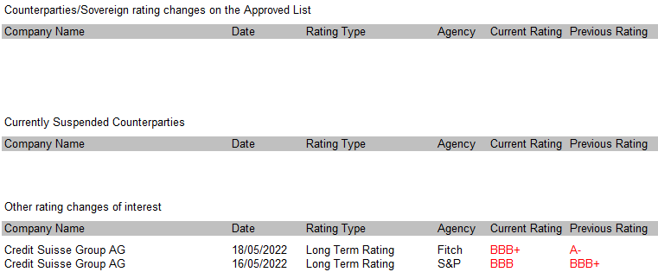
(aiii) Monthly rating changes – May 2022 *- = negative; *+ = positive

Counterparty rating changes
- There were no rating changes of note during the month.

Other news
- Société Générale said it expected the war in Ukraine to lead to a rise in the cost of risk as more customers defaulted on loans and it exited the Russian market. The French bank also reported a 3.4 per cent rise in net income to €842mn for the first quarter compared with a year earlier, and a 16.6 per cent increase in revenues, as it benefited from market volatility and higher interest rates. “The planned disposal, currently being finalised, of our activities in Russia, following the abrupt change in this country’s outlook, will enable the group to withdraw in an effective and orderly manner, ensuring continuity for both its employees and its customers,” said chief executive Frédéric Oudéa. SocGen increased its cost of risk for the year to between 30 and 35 basis points, or up to €1.9bn, having previously disclosed it would be below 30 basis points. Despite the higher cost of risk projections, they were still below analyst estimates.

- UniCredit has put aside €1.3bn to cover potential losses due to its exposure to Russia as the Italian bank considers an exit from the country. The Milan-based lender has a €1.9bn direct exposure to Russia, where it has operated since 2005 through UniCredit Bank Russia, which has more than 70 branches and thousands of staff. UniCredit in April postponed the publication of its quarterly earnings by a week to manage its exposure to Russia. In the worst-case scenario, the Italian lender has warned it could face a loss of €5.3bn if its entire Russian business was wiped out, down from a previous estimate of more than €7bn. This includes derivatives and its €4.5bn cross-border exposure to Russian clients, net of guarantees worth about €1bn. UniCredit is one of several western banks that is considering an exit from the Russian market as sanctions on Moscow make doing business in the country all but impossible for foreign companies.

- HSBC has suspended a senior executive pending an internal investigation into a presentation he made at an event. Stuart Kirk, who is global head of responsible investing at the bank’s asset management division, accused central bankers and policymakers of overstating the financial risks of climate change in an attempt to “out-hyperbole the next guy”. While the bank and its senior executives have criticised, the speech made at a Financial Times conference, its theme and content had been agreed internally before Kirk spoke. The title of the presentation — “Why investors need not worry about climate risk” — had been agreed two months earlier and publicised on the website in the run-up to the event. Kirk’s comments on climate change — which drew anger from environmentalists — were especially embarrassing for the bank as it sponsored the conference and was promoted on the event’s website as a strategic partner. During the speech, Kirk said that throughout his 25-year career in the finance industry “there was always some nut job telling me about the end of the world”, likening the climate crisis to the Y2K bug that predicted a widespread computer glitch at the turn of the millennium. “Unsubstantiated, shrill, partisan, self-serving, apocalyptic warnings are always wrong,” he wrote on a slide accompanying his presentation. (Mr Kirk subsequently resigned on 7 July)

- UK banks and insurers that fail to manage the risks associated with climate change could suffer a 10-15 per cent hit to their annual profits, the Bank of England warned on Tuesday. The results of the regulator’s inaugural “climate stress test” indicated that banks could incur up to £225bn in credit losses by 2050, while insurers’ asset values could fall 15 per cent under a worst-case scenario. But the analysis suggested that the losses would be “absorbable for banks and insurers, without a worrying direct impact on their solvency”, said Sam Woods, head of the BoE’s Prudential Regulation Authority. The exercise will not be used to set higher capital requirements, he said. The stress test looked at the exposure of the largest 19 UK banks and insurers to climate-related risks — both physical risks, such as flooding, and “transition” risks, such as potential regulatory or policy changes. The analysis tested companies’ end-2020 balance sheets against three climate scenarios: an orderly transition, in which temperatures increase to 1.8C of warming by 2050; a disorderly transition where temperatures also increase to 1.8C of warming but action is delayed and more chaotic; and no additional action, where no further policies are introduced, and global temperatures increase by 3.3C relative to pre-industrial levels. The BoE’s stress test envisages that banks and insurers do not change the composition of their balance sheets. The regulators acknowledged that was unlikely to be true in reality. Insurers stood to lose out both from the impact of climate change on their investments and through higher pay-outs for flood and other damage, the BoE said. Insurers’ assets could fall 8 per cent in the most benign scenario, but 15 per cent under the most extreme scenario, with life insurers particularly exposed. Inland and coastal flooding was likely to drive up claims in the UK. In the worst-case scenario, about 7 per cent of UK households that insurers currently cover could become uninsurable, the BoE said. “It’s worth emphasising that these costs would be mostly passed on to consumers through higher premiums,” said Woods.

(av) Monthly rating changes – June 2022 *- = negative; *+ = positive

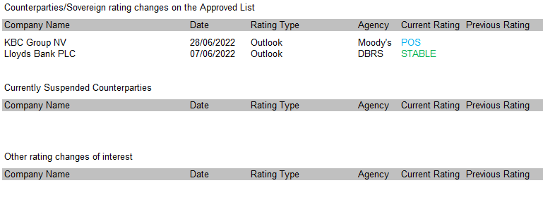

Counterparty rating changes
- Moody's affirmed the A1 long-term deposit ratings of KBC Bank. The outlook on KBC Bank's long-term deposit ratings was changed to positive from stable. The affirmation of KBC reflects high solvency, including strong earnings power, supported by its solid presence in Belgium and Central European countries, and diversified businesses, spanning banking activities, insurance and asset management, which have been providing strong growth in fees. Moody's considers KBC's profitability to be superior to that of most European peers.
KBC has thus far delivered on its strategic plan's objectives, aiming to gain market shares in its core markets and developing its highly integrated model in Belgium and Czech Republic. KBC's ambition to achieve sizable presence in Slovakia, Hungary and Bulgaria through organic growth and acquisitions is also on track. While KBC's direct credit exposure to Russia, Ukraine and Belarus is very small (€55 million), it estimated its indirect exposure (i.e., clients most impacted by newly emerging risks) at circa €8 billion, i.e., 2.2% of its total loan book. KBC thus increased its Stage 2 Expected Credit Loss (ECL) allowance by €223 million in Q1 2022, due to the uncertainties surrounding geopolitical and emerging risks, partly offset by a €205 million reduction in Covid-related forward-looking provisions booked in 2020.
The change of outlook to positive reflects Moody's expectation that KBC's strong earnings generated in recent years will continue to be supported by strong revenue growth, thanks to (i) continued volume growth, and (ii) gradual positive effects from rising interest rates on assets and liabilities, despite headwinds from the macro-economic environment.
Other news
- HSBC, Lloyds Banking Group and Standard Chartered have “shortcomings” in their plans to ensure they could fail without harming customers and taxpayers, the Bank of England said in its first assessment of big lenders’ preparations to manage their demise. The BoE said four other big UK banks must make “enhancements” to their resolution plans. Banks were told to create so-called resolution plans as part of 2019 measures to make sure the bailouts of the 2007-08 crisis would not be repeated, even if lenders were to collapse. Taxpayers were forced to spend tens of billions of pounds rescuing Royal Bank of Scotland and Lloyds in 2008 as their funding dried up. The regulator had committed to parliament that big banks would be “resolvable” by 2022. The UK offshoot of Spain’s Santander was the only one of the UK’s eight top banks that came through the BoE’s assessment without any recommendations for improvement. The BoE stressed that while there were many areas for improvement, all of the banks could fail safely, “remaining open and continuing to provide vital banking services to the economy”.
- BNP Paribas executives told the Dutch government that the French bank would be interested in buying state-owned lender ABN Amro. A meeting between BNP executives and Dutch government officials took place in recent months, with the French bank initially pitching its services as an adviser on stakes of state assets. But during the meeting, the BNP representatives suggested they would be interested in buying ABN themselves. The discussion did not trigger detailed talks. BNP last year agreed to sell its San Francisco-based Bank of the West retail banking unit for $16.3bn, raising expectations that it would use the funds as a war chest and jump on opportunities for acquisitions in Europe. ABN is still majority owned by the Dutch government after it was bailed out during the financial crisis. The State has not sold any shares since September 2017 and Robert Swaak was brought in as chief executive two years ago and tasked with restarting privatisation of the bank.

(B) Bank debt spreads versus UK gilts
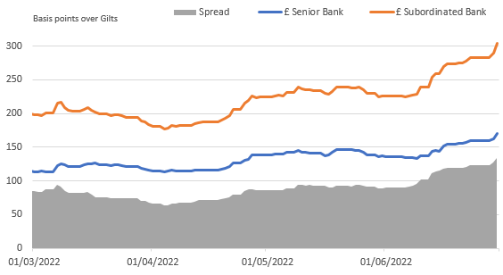
Mar 22 to June 22 - comparison between Senior and Subordinated bank debt
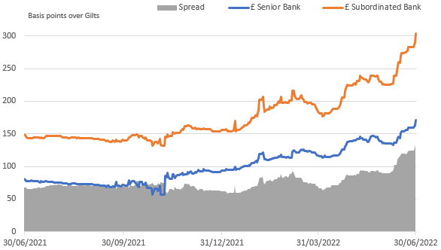
Comparison between Senior and Subordinated bank debt over past 12 months
- In the early part of Quarter 1 Sterling corporate bonds and gilts had already started to re-price on the possibility that the Bank of England would begin Quantitative Tightening, the unfortunate events unfolding in Ukraine has caused an intense rise in yields. The bond markets are pricing in a decent amount of inflation and further rate hikes in the UK and globally.
- The markets continue to adjust to an environment of higher inflation and further rise in yields can be expected. With much uncertainty it is not surprising to see that credit spreads (difference between coprate bonds and gilts) have widen and are now above their the ten-year average.
- Over the past year, all sectors and maturity brackets have seen negative returns. The gilt index is down almost 15% and Corporate Index down 13%. The banking sector down 10%.
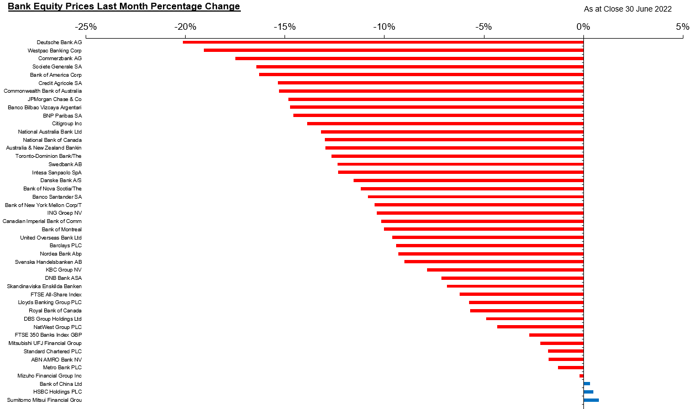
(C) Bank equity prices - (One month and 12-month performance)
- Expectations for UK and global interest rate hikes continue to shift. Using the UK as an example, with the Bank of England's June 16 increase and stark assessment of the economy complicating expectations for more aggressive action. UK base rates may reach 275 bps by December, based on consensus as many as six or seven rate increases are forecast over the next 12 months.
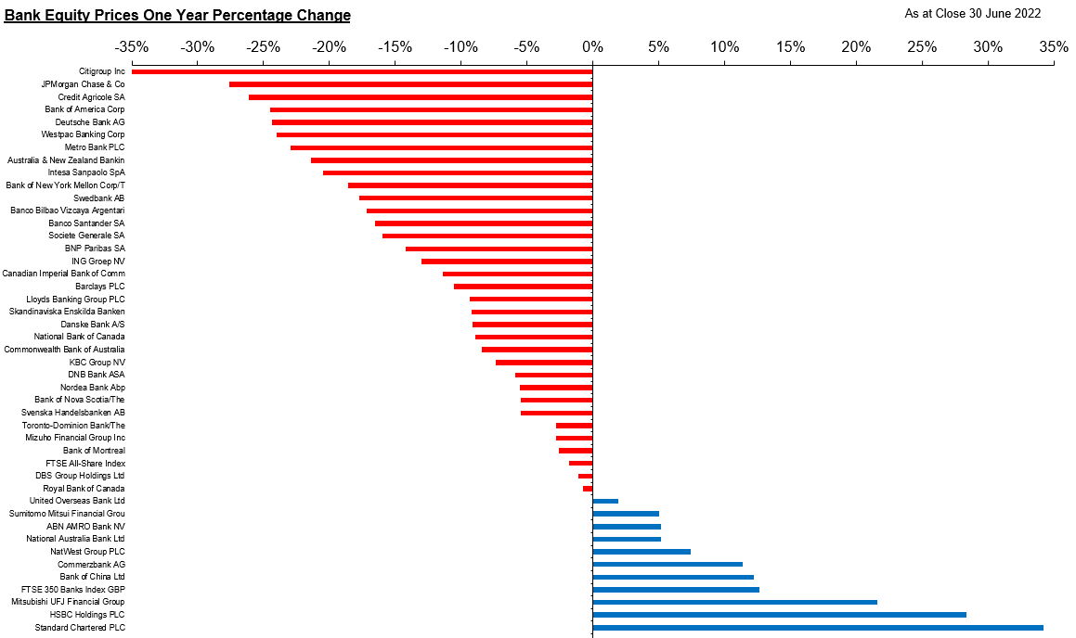
- Though the aggregate year-one revenue gives a boost from the rate increases for the banks, these are offset in terms of rising delinquencies and a slowdown in mortgage and consumer-credit growth. It shows how rapid rate hikes are a mixed blessing for banks, one of the reasons why the majority of bank share prices continue to show negative returns.
(D) CDS Analysis
As part of the daily management of the cash funds a study is undertaken to compare a bank’s Credit Default Swap (CDS) level against the iTraxx Senior Financials Index. CDS spreads can be useful to give an early warning of likely changes in credit ratings. The CCLA Investment Committee agreed that should a bank’s 14 day moving average spread exceed 100 bps at any time then no further deposits should be made with that institution until the situation had been discussed by the Investment Committee.
The cost of insuring financial institution defaults by the end of June had risen to 127 basis points, the highest level in almost a decade. The consequences of the Ukraine conflict, the spike in the rate of inflation to double digits in many regions, and the higher transmission rates in Covid re-emerging are creating nervousness.
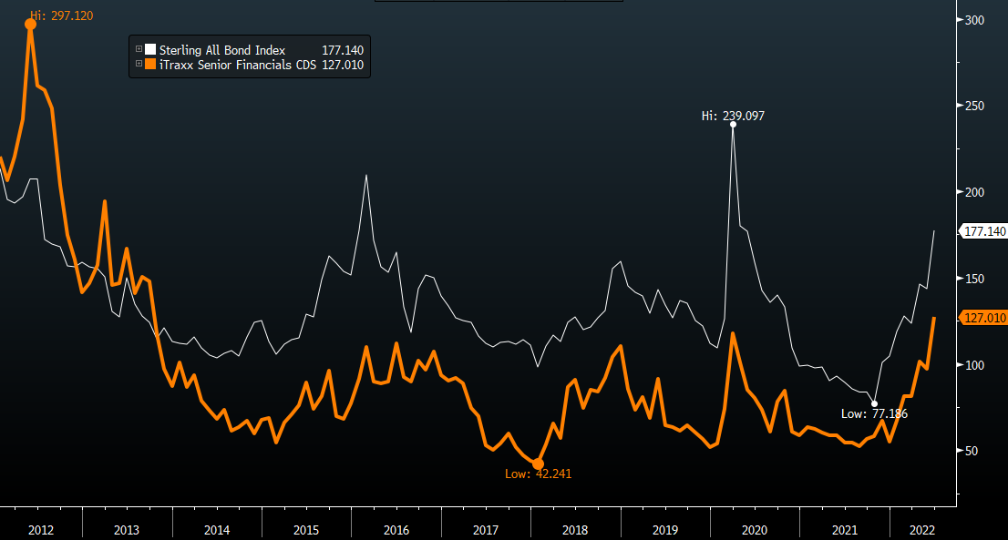
Despite the widening in the index, fortunatelty no banks or financial institutions that we monitor appear on our CDS watchlist.

28 February 2022
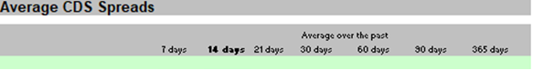
30 June 2022

