**CCLA INVESTMENT MANAGEMENT LIMITED PSDF(22)P11**

**The Public Sector Deposit Fund Advisory Board**

**Current Counterparty Exposures**

**Summary**

* **Exposure to banks domiciled overseas as of 30 June 2022 it was 77.85%**
* **All outstanding investments are within the permitted limits**
* **The largest overseas exposure was to German domiciled banks, followed by the Canadian banks**

With CCLA’s long experience of managing Deposit Funds, it has been possible to establish a comprehensive list of market counterparties. This enables a high degree of diversification while still achieving a competitive yield. The number of authorised financial institutions was 55, of which 35 were utilised.

As previously noted, on 14 January 2019 the CCLA Investment Committee decided to suspend investments with Danske Bank until further details of any fines are made public regarding Money Laundering identified at its Estonian branch. This is scheduled to be reviewed at the July CCLA Investment Committee meeting.

The PSDF Approved List of Financial Institutions as of 30 June 2022

|  |  |  |  |  |  |  |  |  |  |  |  |
| --- | --- | --- | --- | --- | --- | --- | --- | --- | --- | --- | --- |
| PSDF Approved Financial Institutions | Fitch Short | Fitch Long | Fitch  WATCH | Moodys | S&P | DBRS | Rate Criteria | Total  Limit | Total Expos | Limit >7 days | Exposure  > 7 days |
| ABN Amro Bank N.V. | F1 | A |  | P1 | A1 | R1M | Yes | 10% | 3.81 % | 5 % | 2.86 % |
| Bank of America N.A. | F1+ | AA |  | P1 | A1 | R1M | Yes | 10% | 0.00 % | 5 % | 0.00 % |
| Australia and New Zealand Banking Group Limited | F1 | A+ |  | P1 | A1+ | R1H | Yes | 10% | 0.48 % | 5 % | 0.48 % |
| Barclays Bank plc | F1 | A+ |  | P1 | A1 | R1L | Yes | 10% | 3.81 % | 5 % | 3.81 % |
| Barclays Bank UK plc | F1 | A+ |  | P1 | A1 | R1L | Yes | 10% | 0.00 % | 5 % | 0.00 % |
| Bank of Scotland plc | F1 | A+ |  | P1 | A1 | R1M | Yes | 10% | 0.00 % | 5 % | 0.00 % |
| BNP Paribas | F1 | A+ |  | P1 | A1 | R1M | Yes | 10% | 4.29 % | 5 % | 4.29 % |
| Bank of Montreal | F1+ | AA- |  | P1 | A1 | R1H | Yes | 10% | 9.91 % | 5 % | 1.43 % |
| Bank of New York Mellon (The) | F1+ | AA |  | P1 | A1 | R1M | Yes | 10% | 0.00 % | 5 % | 0.00 % |
| Bank of Nova Scotia (The) | F1+ | AA- |  | P1 | A1 | R1H | Yes | 10% | 0.10 % | 5 % | 0.00 % |
| Credit Agricole Corporate and Investment Bank | F1 | A+ |  | P1 | A1 | NR | Yes | 10% | 2.86 % | 5 % | 2.86 % |
| Commonwealth Bank of Australia | F1 | A+ |  | P1 | A1+ | R1H | Yes | 10% | 0.29 % | 5 % | 0.29 % |
| Canadian Imperial Bank of Commerce | F1+ | AA- |  | P1 | A1 | R1H | Yes | 10% | 0.48 % | 5 % | 0.48 % |
| Credit Industriel et Commercial | F1 | A+ |  | P1 | A1 | NR | Yes | 10% | 2.38 % | 5 % | 0.95 % |
| Citibank N.A. | F1 | A+ |  | P1 | A1 | R1M | Yes | 10% | 1.91 % | 5 % | 1.91 % |
| Coventry Building Society | F1 | A- |  | P1 | NR | NR | Yes | 10% | 0.00 % | 5 % | 0.00 % |
| Danske Bank AS (suspended) | F1 | A |  | P2 | A1 | R1L | Yes | 10% | 0.00 % | 5 % | 0.00 % |
| DBS Bank Limited | F1+ | AA- |  | P1 | A1+ | NR | Yes | 10% | 6.67 % | 5 % | 0.00 % |
| DNB ASA | F1+ | AA- |  | P1 | A1+ | R1M | Yes | 10% | 2.38 % | 5 % | 1.43 % |
| Deutsche Zentral-Genossenschaftsbank (DZ Bank AG) | F1+ | AA- |  | P1 | A1 | R1M | Yes | 10% | 4.29 % | 5 % | 4.29 % |
| HM Treasury | F1+ | AA- |  | P1 | A1+ | R1H | Yes | 10% | 0.00 % | 5 % | 0.00 % |
| Handelsbanken plc | F1+ | AA |  | P1 | A1+ | R1M | Yes | 10% | 4.29 % | 5 % | 4.29 % |
| HSBC Bank plc | F1+ | AA- |  | P1 | A1 | NR | Yes | 10% | 0.14 % | 5 % | 0.00 % |
| HSBC UK Bank plc | F1+ | AA- |  | P1 | A1 | NR | Yes | 10% | 0.00 % | 5 % | 0.00 % |
| JP Morgan Chase Bank N.A. | F1+ | AA |  | P1 | A1 | R1H | Yes | 10% | 0.00 % | 5 % | 0.00 % |
| ING Bank N.V. | F1+ | AA- |  | P1 | A1 | R1M | Yes | 10% | 0.00 % | 5 % | 0.00 % |
| KBC Bank N.V. | F1 | A+ |  | P1 | A1 | R1L | Yes | 10% | 0.00 % | 5 % | 0.00 % |
| Landesbank Baden-Wuerttemberg | F1 | A- |  | P1 | NR | R1M | Yes | 10% | 9.91 % | 5 % | 0.00 % |
| Landesbank Hessen-Thueringen Girozentrale | F1+ | A+ |  | P1 | A1 | NR | Yes | 10% | 3.81 % | 5 % | 0.00 % |
| Leeds Building Society | F1 | A- |  | P2 | NR | NR | Yes | 10% | 0.00 % | 5 % | 0.00 % |
| Lloyds Bank plc | F1 | A+ |  | P1 | A1 | R1M | Yes | 10% | 0.00 % | 5 % | 0.00 % |
| Lloyds Bank Corporate Markets plc | F1 | A+ |  | P1 | A1 | R1H | Yes | 10% | 1.91 % | 5 % | 1.91 % |
| Mizuho Bank | F1 | A- |  | P1 | A1 | R1L | Yes | 10% | 0.95 % | 5 % | 0.95 % |
| MUFG Bank | F1 | A- |  | P1 | A1 | R1M | Yes | 10% | 1.91 % | 5 % | 1.91 % |
| National Australia Bank Limited | F1 | A+ |  | P1 | A1+ | R1H | Yes | 10% | 0.00 % | 5 % | 0.00 % |
| Nationwide Building Society | F1 | A |  | P1 | A1+ | R1M | Yes | 10% | 2.57 % | 5 % | 0.00 % |
| NatWest Bank plc | F1 | A+ |  | P1 | A1 | R1L | Yes | 10% | 0.48 % | 5 % | 0.48 % |
| NatWest Markets plc | F1 | A+ |  | P1 | A2 | RIL | Yes | 10% | 2.86 % | 5 % | 2.86 % |
| National Bank of Canada | F1 | A+ |  | P1 | A1 | R1M | Yes | 10% | 0.00 % | 5 % | 0.00 % |
| Nordea Bank AB | F1+ | AA- |  | P1 | A1+ | R1M | Yes | 10% | 4.29 % | 5 % | 3.81 % |
| Oversea Chinese Banking Corporation | F1+ | AA- |  | P1 | A1+ | NR | Yes | 10% | 0.00 % | 5 % | 0.00 % |
| Rabobank | F1 | A+ |  | P1 | A1 | R1H | Yes | 10% | 0.95 % | 5 % | 0.95 % |
| Royal Bank of Canada | F1+ | AA- |  | P1 | A1+ | R1H | Yes | 10% | 1.43 % | 5 % | 1.43 % |
| Santander UK plc | F1 | A+ |  | P1 | A1 | NR | Yes | 10% | 1.52 % | 5 % | 1.43 % |
| Skandinaviska Enskilda Banken AB | F1+ | AA- |  | P1 | A1 | R1M | Yes | 10% | 0.48 % | 5 % | 0.48 % |
| SMBC Bank | F1 | A |  | P1 | A1 | R1M | Yes | 10% | 0.00 % | 5 % | 0.00 % |
| SMBC Bank International plc | F1 | A |  | P1 | A1 | R1M | Yes | 10% | 4.29 % | 5 % | 4.29 % |
| Sumitomo Mitsui Trust Bank | F1 | A- |  | P1 | A1 | NR | Yes | 10% | 0.95 % | 5 % | 0.95 % |
| Societe Generale | F1 | A- |  | P1 | A1 | R1M | Yes | 10% | 0.00 % | 5 % | 0.00 % |
| Standard Chartered Bank plc | F1 | A+ |  | P1 | A1 | NR | Yes | 10% | 0.95 % | 5 % | 0.95 % |
| Toronto Dominion Bank (The) | F1+ | AA- |  | P1 | A1+ | R1H | Yes | 10% | 2.86 % | 5 % | 2.86 % |
| UBS AG | F1+ | AA- |  | P1 | A1 | R1M | Yes | 10% | 1.91 % | 5 % | 1.91 % |
| United Overseas Bank Limited | F1+ | AA- |  | P1 | A1+ | NR | Yes | 10% | 0.00 % | 5 % | 0.00 % |
| Westpac Banking Corporation | F1 | A+ |  | P1 | A1+ | R1H | Yes | 10% | 0.00 % | 5 % | 0.00 % |
| Yorkshire Building Society | F1 | A- |  | P2 | NR | NR | Yes | 10% | 7.91 % | 5 % | 0.00 % |

Investments were all made, within the agreed limits, at the time of execution.

The PSDF Analysis of Country Exposure as of 30 June 2022

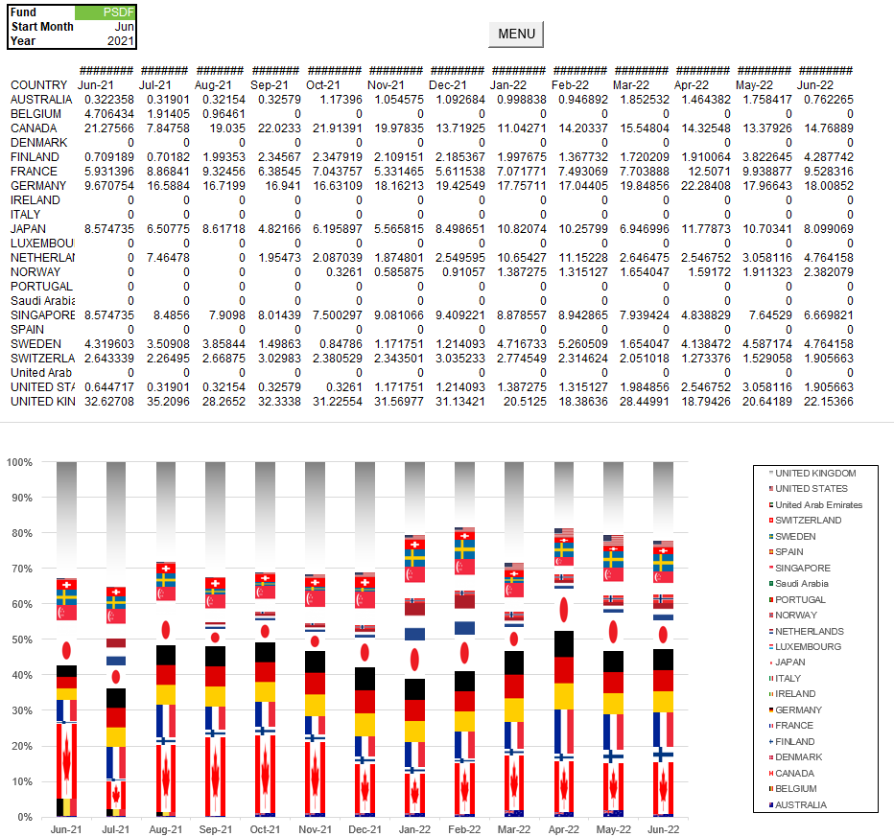

There has been no material change, the PSDF lent 77.85% (Feb 22: 81.61%) to banks domiciled overseas. The largest overseas country exposure was 18.01% (Feb: 17.04%) to German domiciled banks followed by 14.77% (Feb: 14.20%) to Canadian domiciled banks.

Excluding the zero weightings, the smallest exposure is with the Australian banks.